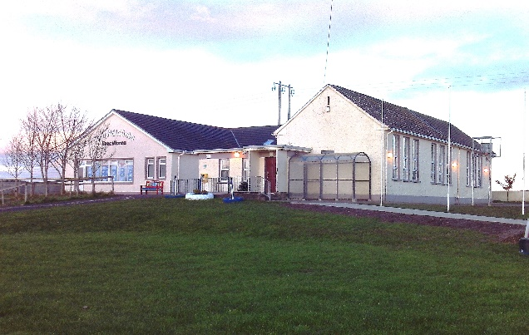

Knockminna N.S., Ballymote, Co.Sligo
Roll No. 18334F
Admissions Application Form 2026/2027
Pupil’s Details:  First Name:  Last Name:  Male/Female:  Date of Birth:  P.P.S. Number:  Home Address:  Eircode:  Intended Class:  Country of Birth:  Nationality:  If other than Irish, please state  date of arrival in Ireland:  Languages spoken  in the home: | Parent/Guardian Details  First Name:  Last Name:  Relationship to child:  Home phone number:  Work phone number:  Mobile phone number:  E-mail address:
Parent/Guardian Details
First Name:

Last Name:

Relationship to child:

Home phone number:

Work phone number:

Mobile phone number:

E-mail address:

Additional Details:
(Please fill where applicable)
Name of Previous School/Pre-School:

Address:

Principal/Manager’s Name:

Phone Number:

Are there any orders or other arrangements in place, governing access to or custody of your child? |  | Yes | No
The school may share Personal Pupil Data with other organisations such as HSE, Tusla, An Garda Síochána, etc., where there is a legal basis for doing so under GDPR

Emergency Contact Details: (not the same as those already provided)

Name:

Phone number:

Relationship to the child:

Name:

Phone number:

Relationship to the child:

Name:

Phone number:

Relationship to the child:

Relevant Medical Information:

Family Doctor: |  |  | Phone No.:
Has your child any medical  condition/known allergies/other issues  that the school should be aware of? | Yes | No | Details
Has your child attended speech therapy?

Has your child attended Occupational therapy?

Has your child attended an Educational Psychologist?

Has your child any other Special Educational Needs?

Please enclose copies of any relevant assessments

In the event of an accident occurring during school hours, which would necessitate medical attention, your child may be seen by any available doctor or taken to the accident and emergency department of Sligo General Hospital as deemed appropriate by staff at the time.

Agree

Disagree

Signed:_________________ Date:_______________

Permission Details

I give permission for my child to undertake activities outside the school premises e.g. visiting the church/library, going on nature walks, taking part in sporting events etc.

Yes No

I give permission for my child to use technological devices in the school (e.g. IPads/Interactive Smart TV’s etc.) in line with our Acceptable Use Policy

Yes No

I give permission for my child’s photo/video clip to appear on the Knockminna N.S. website/Social Media Platforms or in publications (e.g. local newspapers) pertaining to school related activities or successes. Children will never be identified individually.

Yes No

As directed by the Department of Education & Skills, the school uses the ‘Stay Safe’, ‘Walk Tall’ and ‘Relationships and Sexuality’ (RSE) education programmes as part of the SPHE (Social, Personal and Health Education) curriculum. I give permission for my child to take part in these lessons.

Yes No

I give permission for diagnostic tests to be carried out on my child. (These tests may be necessary from time to time in order to assist with your child’s educational development. They will be discussed with you in the event that your child needs further intervention)

Yes No

I give permission for my child to be withdrawn by the Learning Support teacher in a class/small group for extra tuition in varying aspects of literacy and numeracy

Yes No

I have read a copy of Knockminna National School’s Code of Behaviour and Discipline and also the Bí Cineálta Anti-Bullying Policy (both available on http://www.knockminnans.ie or please request copies directly from the school if you cannot access them) I agree that my child and I will abide by these policies and support the ethos of the school while attending Knockminna N.S. and any school related activities.

Yes No

I give permission for my child to enter school competitions and for their name and date of birth to be shared with the organisers.

Yes No

Signed: ___________________ Date:______________________

School Transport:

Please note: Information in relation to school transport can be accessed on www.buseireann.ie/schooltransport

